CTU19 – Introduction to Vibrational Spectroscopy
Teacher: prof. Dr. RNDr. Pavel Matějka
Address: University of Chemistry and Technology Prague
Technická 5, 166 28 Prague 6
The University is situated in the northwest direction of metro station Dejvická, near Vítězné náměstí in Prague 6.
The University occupies three buildings in Dejvice (see the map below):
- Building A - Technická 5 – ATHENS course
- Building B - Technická 3
- Building C - Studentská 6
How to get to the University:
From the hostel:
Metro line B, destination Zličín; change for line A at the station Můstek, destination Dejvická. The trip takes approx. 25 min.
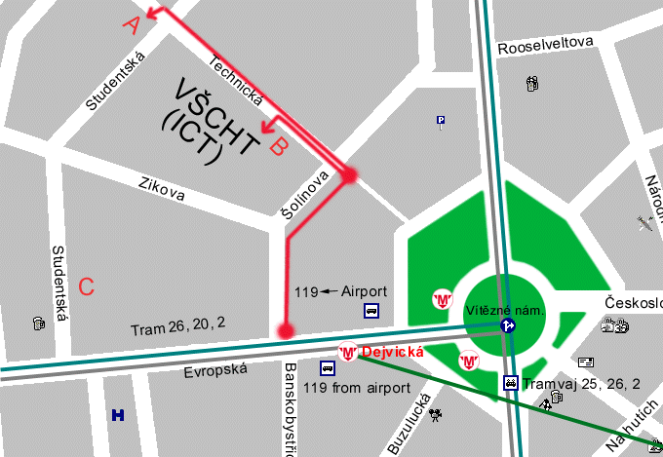
The following map shows the location of our buildings in Dejvice:

Meeting point: Monday March 13, 2017, 8:50 AM
at porter's lodge of building A,
University of Chemistry and Technology Prague
Technicka 5, Prague 6

