**CTU10- The PIV Method in Fluid Mechanics**

**Prof. Ing. Jiří Nožička CSc., Ing Jan Novotný Ph.D.**

Czech Technical University in Prague  
Faculty of Mechanical Engineering (CTU FME)  
Department of Fluid Dynamics and Termodynamics  
Technicka 4,  
CZ-166 27 Praha 6, Czech Republic

How to get to us:

**Map:**

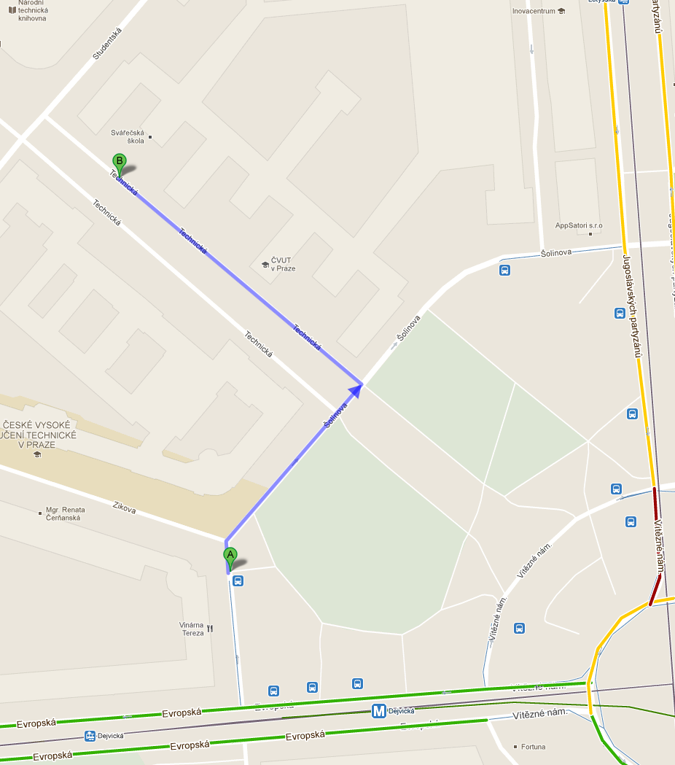

**Meeting point in lobby of Faculty of Mechanical Engineering CTU in Prague**, **Monday 13.3. 2017 at 10 00**

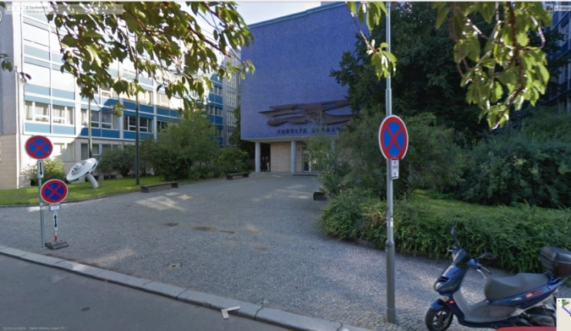

**Output station Dejvická**

**From the A plus hostel:** Underground (Metro) line C to Museum (2-st)   
Change to the line A and go to the Dejvicka station.